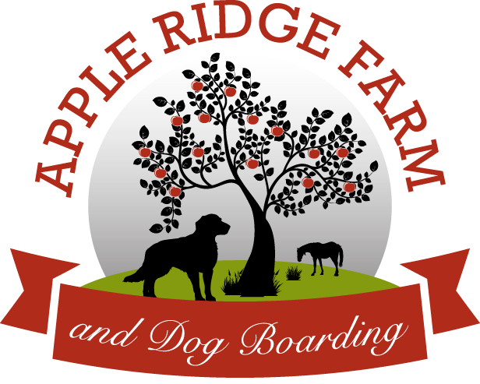
The VIP (very important pets)

NEWSLETTER June 2021
  - Apple Ridge Farm, 34 Caintown Rd, Mallorytown | Phone: 613.923.5357 | website: www.appleridgefarm.ca

Beat the summer heat - Dogs get heat stroke too .... !

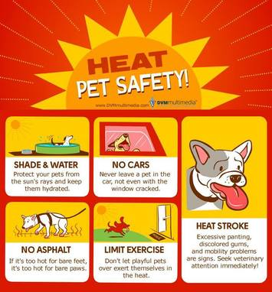
As the weather heats up, this could mean plenty of outdoor fun for you and your pup! While spending more time outdoors can be a great way to burn off excess energy and can be fun for all involved, the summer heat can be very taxing on your dog. Unfortunately, our pups don’t have the efficient ‘cooling system’ that us humans have – sweat. Therefore, they can easily become overheated and even suffer a heat stroke! Keep your pup cool and safe this summer with these easy tips:

KEEP YOUR DOG HYDRATED One of the easiest and most effective ways of cooling off your pup is by keeping them hydrated with some fresh cool water. You can do this by carrying around a portable, collapsible water bowl and bottles of cold water. It is important to ensure your pup is drinking water every hour when exposed to hot weather conditions. If you notice your dog is panting excessively, get them into the shade and offer more water immediately.

ENJOY SOME WATER ACTIVITIES What better way to help your pup beat the heat than by going for a swim or enjoying some water play activities? A kiddie pool or a yard sprinkler are great ways for your pup to get in some much-needed exercise while enjoying the summer weather.

PROVIDE YOUR PUP WITH SOME FROZEN TREATS A tasty frozen treat such as frozen broth cubes, frozen yogurt, frozen banana popsicles, Frosty Paws and frozen Kong’s can help refresh your pup! ARF has lots of frozen treat choices.
KNOW THE SIGNS OF HEATSTROKE IN DOGS AND WHAT TO DO Heatstroke is a serious danger to pups during hot summer days, especially to those with health issues. Take note of the following signs of heatstroke in your dog: Excessive panting and salivating, Vomiting and diarrhea, Seizures, Disorientation, Clear discomfort. If you witness any of these warning signs, immediately get your pup into a cooler environment and call your veterinarian. Immediate veterinary care can prevent further complications and treat any existing ones.

Bring your Fur friend to Apple ridge farm Bring your pup to Apple Ridge Farm for a fun-filled day of safe play outdoors as well as in our climate-controlled playroom. Add on a cool frosty paw treat or bring them for water activity fun, we keep your pup comfortable in the perfect temperature during playtime with our central air and HVAC systems that also help keep the air fresh and clean. You can keep your mind at ease knowing that your dog is enjoying the safe – and cool – exercise and socialization they need to become a healthy, well-rounded pup.
New Farm Update:
- Book early for your Canada day festivies, we have some fun events planed for your pups!
- Online payment method, Pay in your pet parent portal, your email invoice or by E-Transfer with invoice# arfepay@gmail.com
- FROSTY PAWS ARE BACK - $1 each or 6 for $5.
- Holly is Celebrating 1 year Employed with Apple Ridge Farm.
- ARF is requesting all daycares be paid at time of booking, % 50 is requested at time of booking for boarding & updated policys.
- How to: Pet parent portal tutorials have arrived visit our website--- http://www.appleridgefarm.ca/online-booking-tutorials.html
- Fathers day is June 20th get that hard to get for dad a gift he will love– Gift cards available. Paw portraits available June 13th - 21st
- PRE BOOKING your Daycare and Baording visits EARLY so you wont be disapointed! The farm is filling quicker and quicker.

